In this demo project we have created four classes

1. Student
2. Student_Repository
3. StudentController
4. Student_services

* Student is model class where we are saving the roll no and name of the student
* In Student Controller we have mapped CRUD operation with respected end points
* In student service class we define the methods

Here we are adding the data in our DB using save function

http://localhost:8090/addstudent

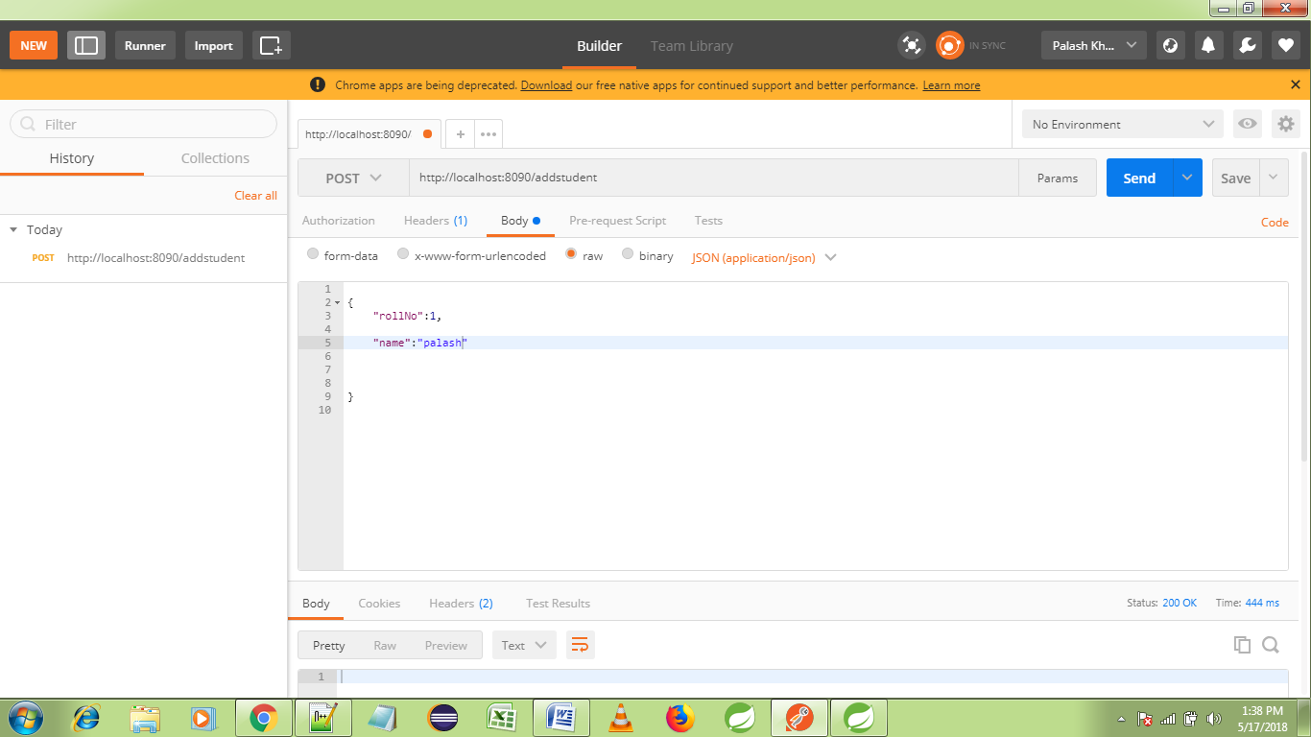

Here we are fetching all the results save in db by findAll method

http://localhost:8090/AllStudent

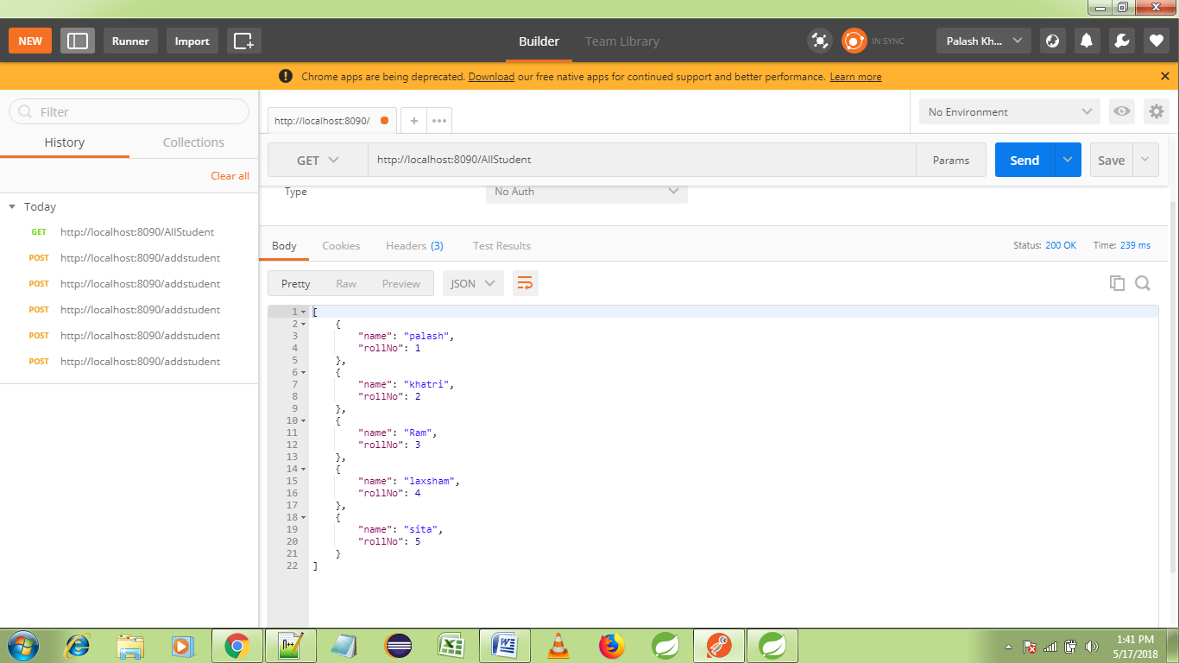

Here we are fetching only one result according to our ID / roll no

http://localhost:8090/onestudent/1

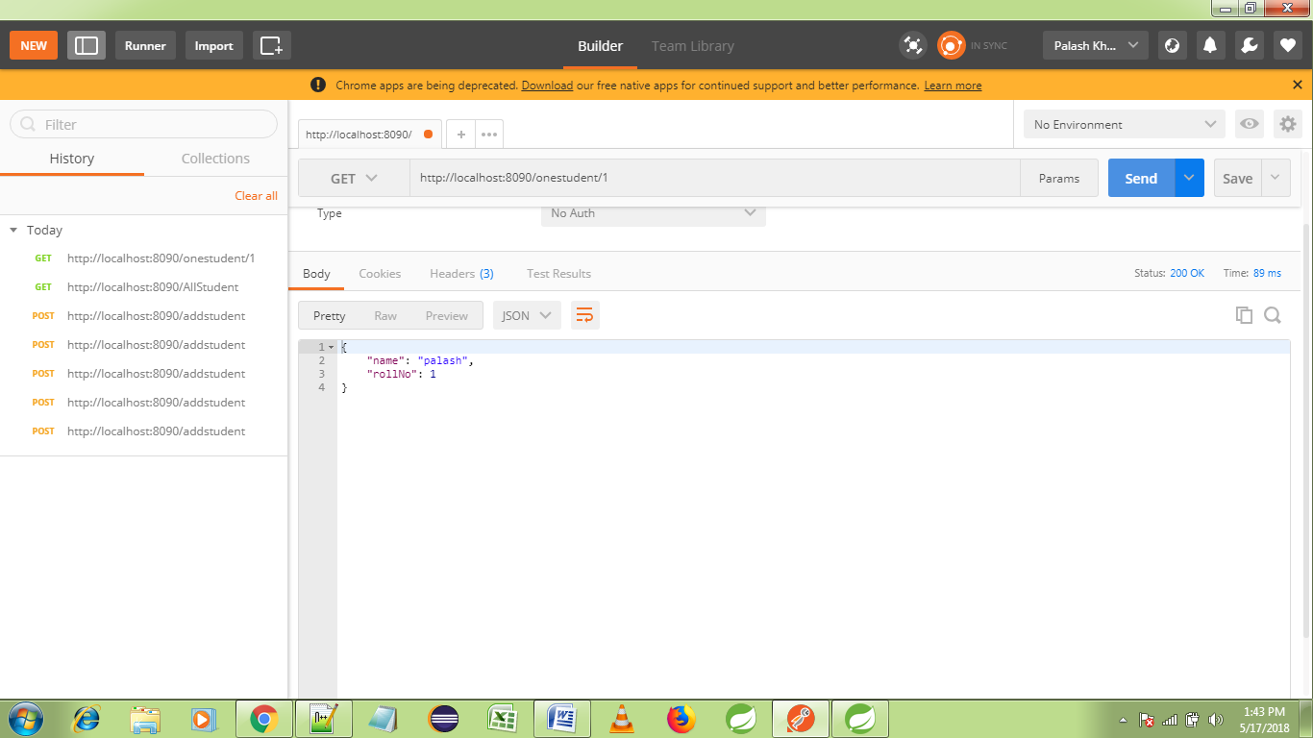

Here we updated the value of one result by using particular ID

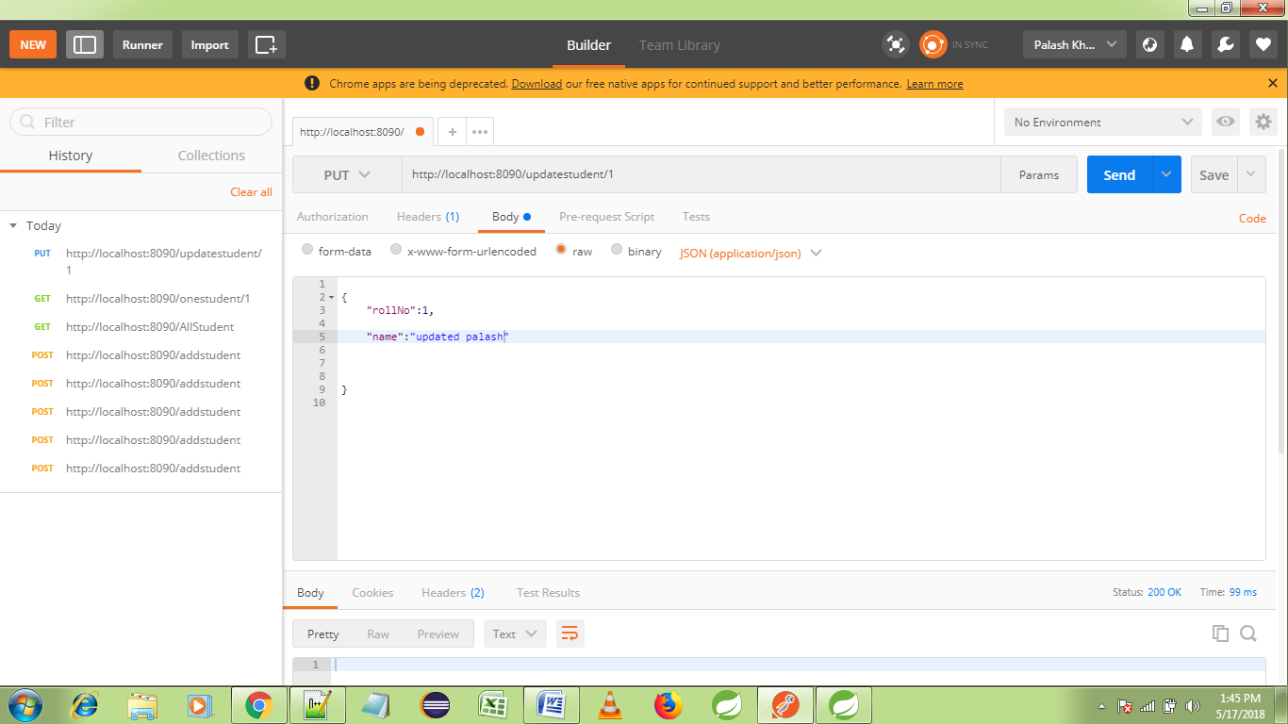

When search with same id/roll no we get updated result

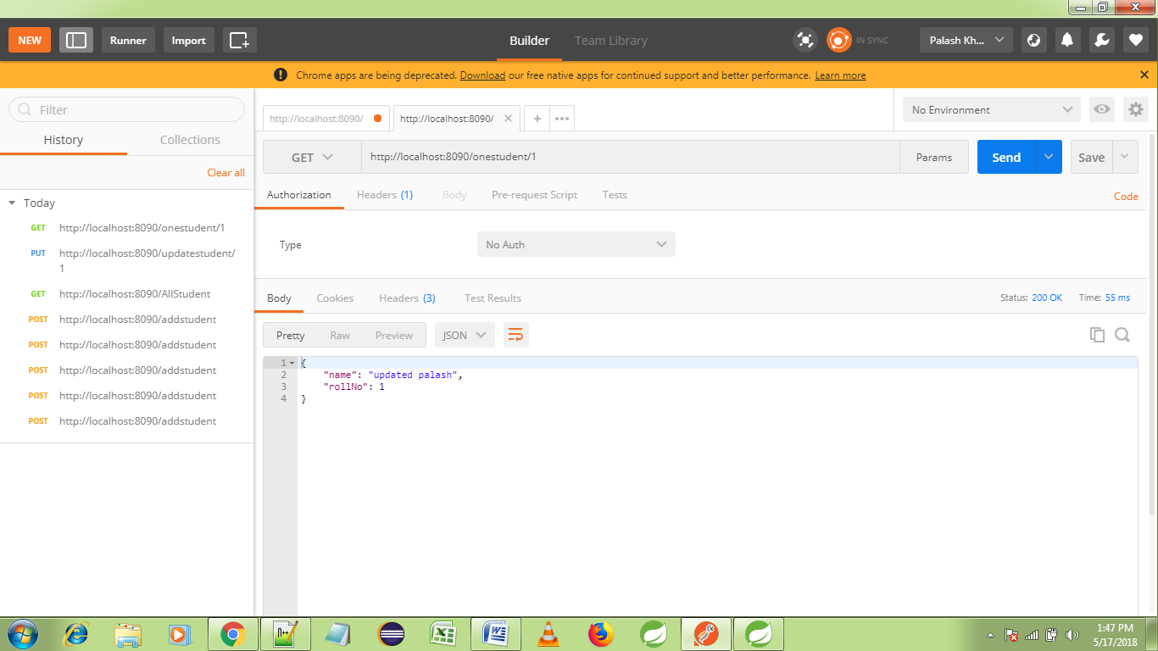

Have deleted the record with id =1

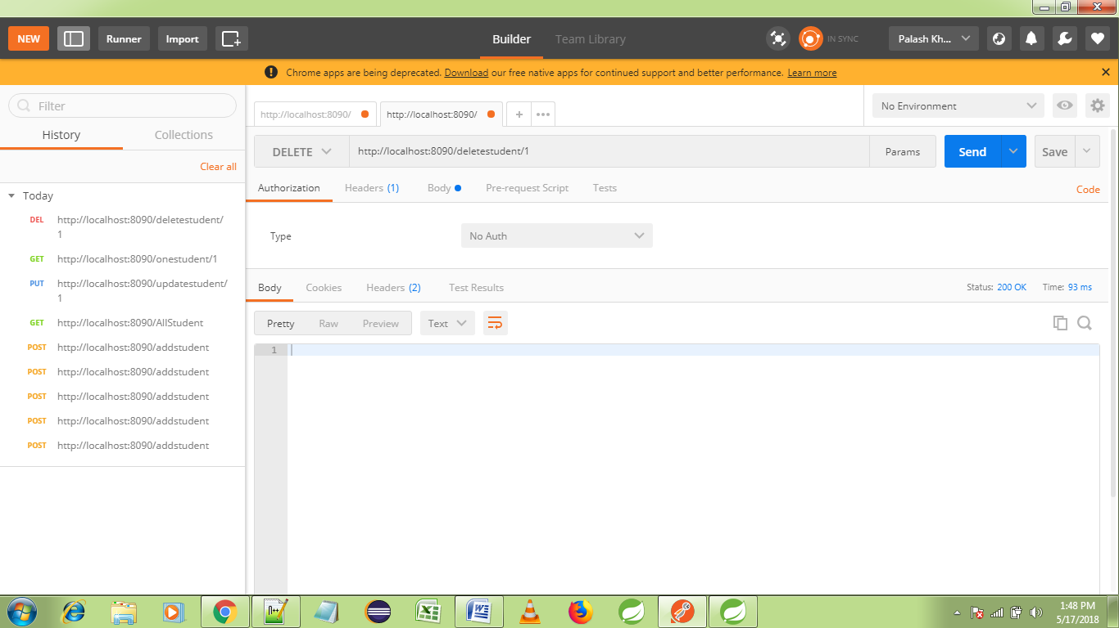

On searching no result found

